
Flask & MongoDB
DEVOPS | Assignment
Objective: Build a Flask application with a JSON API route and a frontend form that stores submitted data in MongoDB Atlas, with proper success and error handling.

Task 1: JSON API Route
- Create a Flask application with an /api route. When this route is accessed, it should return a JSON list. The data should be stored in a backend file, read from it, and sent as a response.

app.py
from flask import Flask, jsonify
from backend import data

app = Flask(__name__)

@app.route('/api')
def api():
return jsonify(data)

if __name__ == "__main__":
app.run(debug=True)

backend.py
data = [
{
"name" : "Lakshit Tyagi",
"age" : 20,
"city" : "New Delhi"
},
{
"name" : "Sonu Dhiman",
"age" : 25,
"city" : "Noida"
},
{
"name" : "Rohit Sharma",
"age" : 30,
"city" : "Mumbai"
},
{
"name" : "Mohit Tyagi",
"age" : 35,
"city" : "Bangalore"
}
]
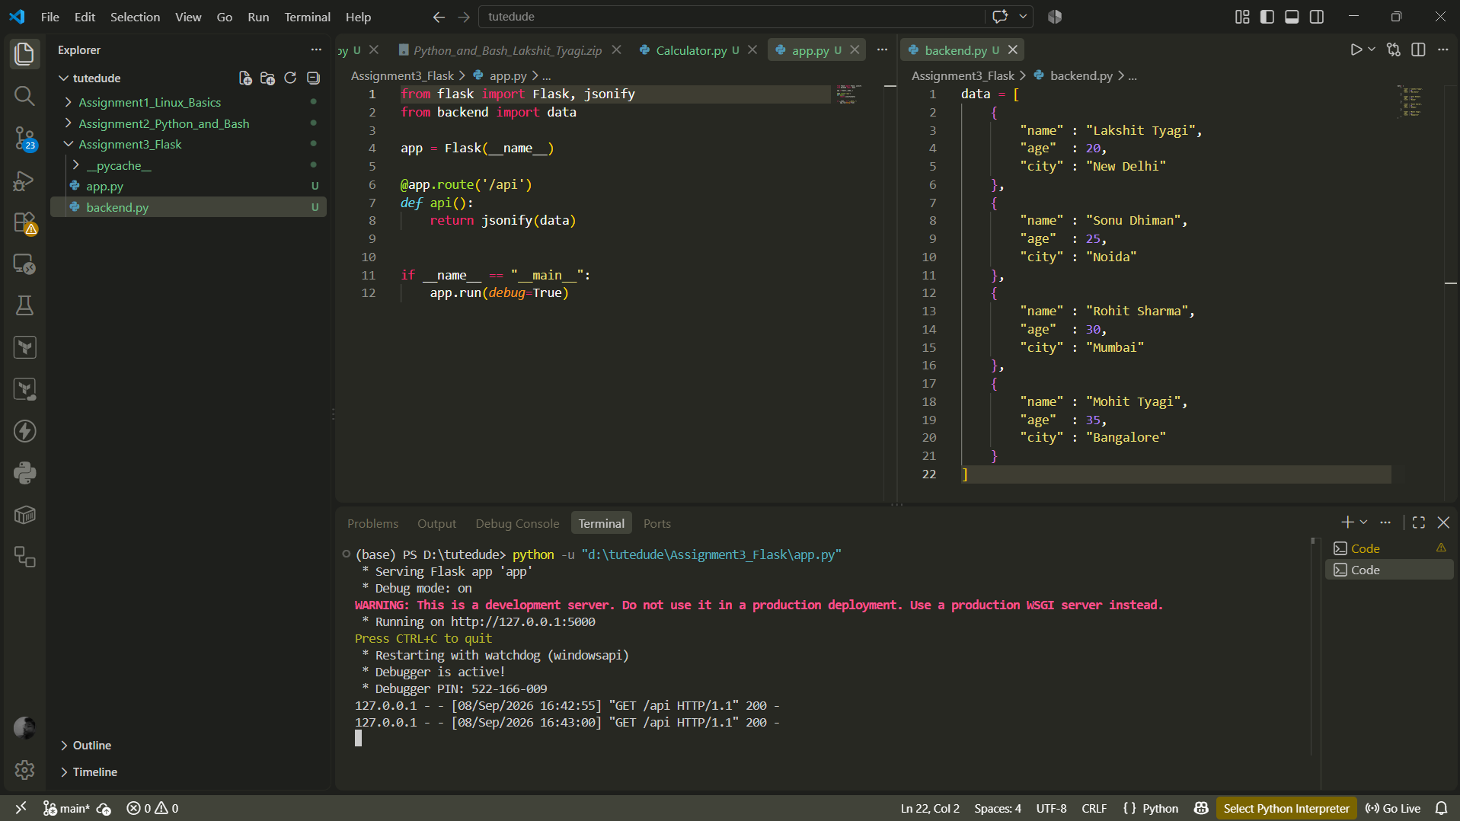
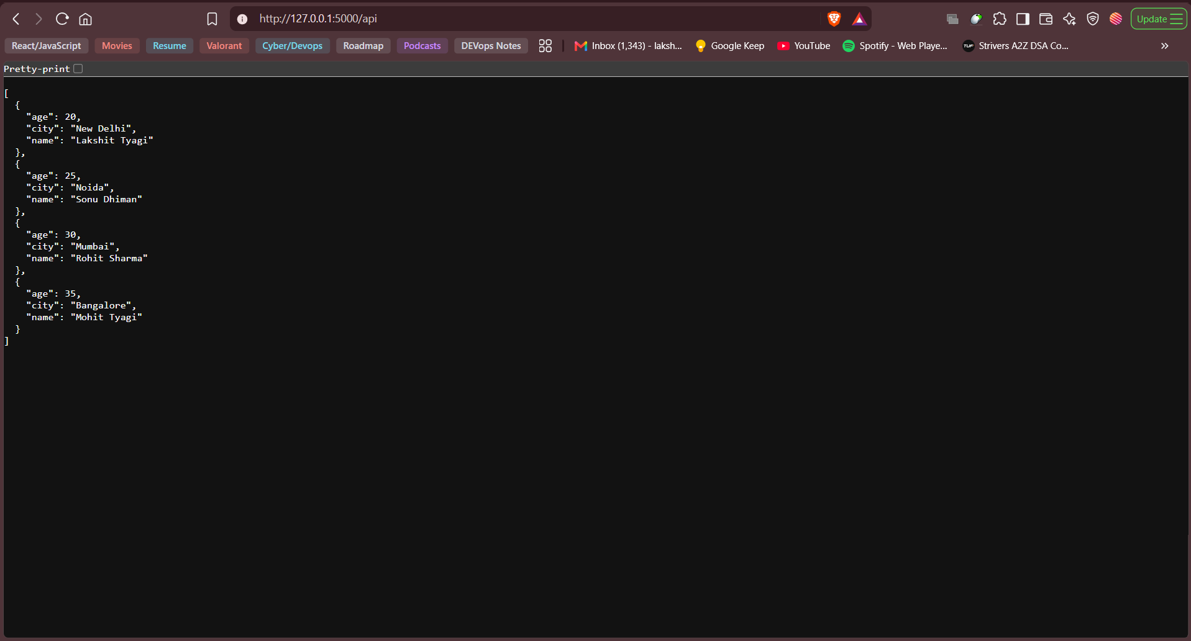

Task 2: Frontend Form with MongoDB Atlas
- Create a form on the frontend that, when submitted, inserts data into MongoDB Atlas.
- On success: the user should be redirected to another page displaying the message “Data submitted successfully”.
- On error: display the error on the same page without redirection.

\backend\app.py
from flask import Flask, request, jsonify
import pymongo
from dotenv import load_dotenv
import os

load_dotenv()

MONGO_URI = os.getenv("MONGO_URI")

client = pymongo.MongoClient(MONGO_URI)

db = client.flask
collection = db["flask_Tutorial"]

app = Flask(__name__)

@app.route('/submit', methods=['POST'])
def submit():
form_data = dict(request.form)
collection.insert_one(form_data)
return "Data submitted successfully!"

# @app.route('/submit', methods=['POST'])
# def submit():

# form_data = dict(request.form)

# # SIMULATE ERROR
# raise Exception("Testing error handling!")

# collection.insert_one(form_data)

# return "Data submitted successfully!", 200

@app.route('/data', methods=['GET'])
def get_data():

data = list(collection.find({}, {'_id': 0}))
return jsonify(data)

if __name__ == '__main__':
app.run(debug=True, port=5001)

\frontend\app.py
from flask import Flask, request, jsonify
import pymongo
from dotenv import load_dotenv
import os

load_dotenv()

MONGO_URI = os.getenv("MONGO_URI")

client = pymongo.MongoClient(MONGO_URI)

db = client.flask
collection = db["flask_Tutorial"]

app = Flask(__name__)

@app.route('/submit', methods=['POST'])
def submit():
form_data = dict(request.form)
collection.insert_one(form_data)
return "Data submitted successfully!"

# @app.route('/submit', methods=['POST'])
# def submit():

# form_data = dict(request.form)

# # SIMULATE ERROR
# raise Exception("Testing error handling!")

# collection.insert_one(form_data)

# return "Data submitted successfully!", 200

@app.route('/data', methods=['GET'])
def get_data():

data = list(collection.find({}, {'_id': 0}))
return jsonify(data)

if __name__ == '__main__':
app.run(debug=True, port=5001)

frontend\templates\index.html
<!DOCTYPE html>
<html lang="en">

<head>
<meta charset="UTF-8">
<meta name="viewport" content="width=device-width, initial-scale=1.0">

<title>Student Form</title>

<style>
* {
box-sizing: border-box;
margin: 0;
padding: 0;
}

body {
font-family: Arial, Helvetica, sans-serif;
min-height: 100vh;
display: flex;
justify-content: center;
align-items: center;
background: #f4f7fb;
color: #1f2937;
}

.container {
width: 100%;
max-width: 450px;
background: white;
padding: 35px;
border-radius: 16px;
box-shadow: 0 10px 30px rgba(0, 0, 0, 0.08);
}

h1 {
text-align: center;
margin-bottom: 10px;
font-size: 28px;
color: #111827;
}

.date {
text-align: center;
color: #6b7280;
margin-bottom: 30px;
font-size: 15px;
}

form {
display: flex;
flex-direction: column;
}

label {
margin-bottom: 7px;
font-size: 14px;
font-weight: 600;
color: #374151;
}

input {
width: 100%;
padding: 12px 14px;
margin-bottom: 20px;
border: 1px solid #d1d5db;
border-radius: 8px;
font-size: 15px;
outline: none;
transition: border-color 0.2s, box-shadow 0.2s;
}

input:focus {
border-color: #4f46e5;
box-shadow: 0 0 0 3px rgba(79, 70, 229, 0.12);
}

button {
border: none;
padding: 13px;
border-radius: 8px;
background: #4f46e5;
color: white;
font-size: 15px;
font-weight: 600;
cursor: pointer;
transition: background 0.2s, transform 0.1s;
}

button:hover {
background: #4338ca;
}

button:active {
transform: scale(0.98);
}

.data-link {
display: block;
text-align: center;
margin-top: 22px;
color: #4f46e5;
text-decoration: none;
font-size: 14px;
font-weight: 600;
}

.data-link:hover {
text-decoration: underline;
}

.error {
background: #fee2e2;
color: #b91c1c;
padding: 10px;
border-radius: 8px;
margin-bottom: 20px;
font-size: 14px;
}
</style>

</head>

<body>

<div class="container">

<h1>Student Form</h1>

<p class="date">Today is {{ day_of_week }}</p>

{% if error %}
<p class="error">{{ error }}</p>
{% endif %}

<form action="/submit" method="POST">

<label for="name">Name</label>
<input
type="text"
id="name"
name="name"
placeholder="Enter your name"
required
>

<label for="age">Age</label>
<input
type="number"
id="age"
name="age"
placeholder="Enter your age"
min="1"
required
>

<label for="city">City</label>
<input
type="text"
id="city"
name="city"
placeholder="Enter your city"
required
>

<button type="submit">Submit</button>

</form>

<a class="data-link" href="/data">
View Submitted Data →
</a>

</div>

</body>

</html>

\frontend\templates\data.html
<!DOCTYPE html>
<html lang="en">

<head>

<meta charset="UTF-8">
<meta name="viewport" content="width=device-width, initial-scale=1.0">

<title>Submitted Data</title>

<style>

* {
box-sizing: border-box;
margin: 0;
padding: 0;
}

body {
font-family: Arial, Helvetica, sans-serif;
min-height: 100vh;
background: #f4f7fb;
color: #1f2937;
padding: 40px;
}

.container {
max-width: 1100px;
margin: auto;
}

h1 {
text-align: center;
margin-bottom: 35px;
font-size: 30px;
color: #111827;
}

.content {
display: grid;
grid-template-columns: 1fr 1fr;
gap: 25px;
}

/* LEFT SIDE */

.records {
background: white;
padding: 25px;
border-radius: 16px;
box-shadow: 0 10px 30px rgba(0, 0, 0, 0.08);
}

.records h2,
.json-section h2 {
margin-bottom: 20px;
font-size: 20px;
color: #111827;
}

.record {
border: 1px solid #e5e7eb;
border-radius: 10px;
padding: 18px;
margin-bottom: 15px;
background: #fafafa;
}

.record:last-child {
margin-bottom: 0;
}

.field {
display: flex;
justify-content: space-between;
padding: 8px 0;
border-bottom: 1px solid #e5e7eb;
}

.field:last-child {
border-bottom: none;
}

.field-name {
font-weight: 600;
color: #4b5563;
}

.field-value {
color: #111827;
}

/* RIGHT SIDE */

.json-section {
background: white;
padding: 25px;
border-radius: 16px;
box-shadow: 0 10px 30px rgba(0, 0, 0, 0.08);
}

.json-box {
background: #111827;
color: #e5e7eb;
padding: 20px;
border-radius: 10px;
overflow-x: auto;
min-height: 300px;
max-height: 500px;
}

pre {
margin: 0;
font-family: Consolas, Monaco, monospace;
font-size: 14px;
line-height: 1.6;
white-space: pre-wrap;
word-wrap: break-word;
}

.copy-button {
width: 100%;
margin-top: 15px;
padding: 12px;
border: none;
border-radius: 8px;
background: #4f46e5;
color: white;
font-size: 15px;
font-weight: 600;
cursor: pointer;
transition: background 0.2s, transform 0.1s;
}

.copy-button:hover {
background: #4338ca;
}

.copy-button:active {
transform: scale(0.98);
}

/* BOTTOM LINK */

.back-link {
display: block;
width: fit-content;
margin: 30px auto 0;
color: #4f46e5;
text-decoration: none;
font-weight: 600;
}

.back-link:hover {
text-decoration: underline;
}

/* MOBILE */

@media (max-width: 800px) {

body {
padding: 20px;
}

.content {
grid-template-columns: 1fr;
}

}

</style>

</head>

<body>

<div class="container">

<h1>Submitted Data</h1>

<div class="content">

<!-- LEFT SIDE -->

<div class="records">

<h2>Student Records</h2>

{% for document in data %}

<div class="record">

<div class="field">
<span class="field-name">Name</span>
<span class="field-value">
{{ document.name }}
</span>
</div>

<div class="field">
<span class="field-name">Age</span>
<span class="field-value">
{{ document.age }}
</span>
</div>

<div class="field">
<span class="field-name">City</span>
<span class="field-value">
{{ document.city }}
</span>
</div>

</div>

{% endfor %}

</div>

<!-- RIGHT SIDE -->

<div class="json-section">

<h2>JSON Response</h2>

<div class="json-box">

<pre id="jsonData">{{ data | tojson(indent=4) }}</pre>

</div>

<button class="copy-button" onclick="copyJSON()">
Copy JSON
</button>

</div>

</div>

<a class="back-link" href="/">
← Back to Form
</a>

</div>

<script>

function copyJSON() {

const json = document.getElementById("jsonData").innerText;

navigator.clipboard.writeText(json);

const button = document.querySelector(".copy-button");

button.innerText = "Copied!";

setTimeout(() => {
button.innerText = "Copy JSON";
}, 1500);
}

</script>

</body>

</html>

